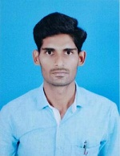

SAKTHIVEL E
2/3 Kooliganur,
Gummanur (PO),
Palacode (TK),
Dharmapuri (DT). E-mail: shakthi9294@gmail.com
PIN-635116 Phone No: 9488975414

PROFESSIONAL OBJECTIVE:
To work in association with professional groups who offer me the opportunity for career advancement and professional growth.

ACADEMIC EXCELLENCE:
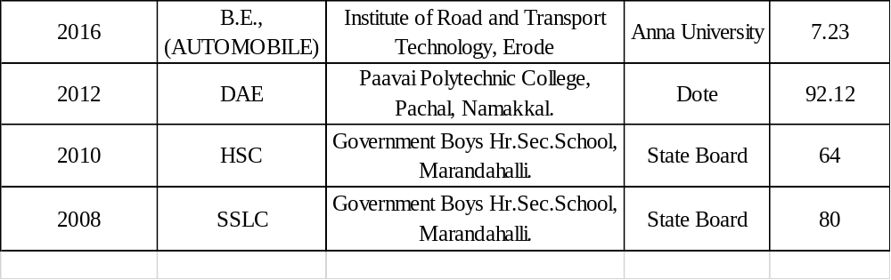
EXPERIENCE:
- Apprentice (1year), Assembly #2, Hyundai motors India, Chennai.
- Staff Training ( junior Engineer), Maintenance Department, Mechanical and
Electrical, 2 years (present), Rajsriya Automotive Industry Pvt.Ltd, Hosur.

SOFTWARE SKILLS:
- AUTOCAD
- Creo

DOMAIN OF INTEREST:
- Automobile Engineering.
- Manufacturing Technology.

PROJECTS:
- Reverse rotating disc brake rotor.
- Performance and emission test on bio-diesel and Methanol

STRENGTH:
- Consistently good academic record.
- Hard worker and adaptive in Challenging circumstances.
- Good Leadership Quality.

EXTRA CURRICULAR ACTIVITIES:
- Actively participated Paper presentation on CIPET, Chennai.
- Actively participated Science and Technology capacity Building for Industrial Needs on Paavai Polytechnic College, Namakkal.

PERSONAL INFORMATION:

Name | : SAKTHIVEL.E
Father's Name | : ELANGO.P
Date of birth | : 04-03-1992
Sex  Religion | : Male  : Hindu
Language known | : English, Tamil, Kannada, Telugu
Nationality | : Indian

DECLARATION:

I hereby declare that the above information is true to the best of my knowledge.

PLACE: Dharmapuri Yours truly,

(SAKTHIVEL)

